**Optimizing emergency responses: developing operations research tools for Flood response in Bangladesh**

Contributors: Md Mahbubar Rahman, Tanmoy Das, Riad Alam, Hafizur Rahman

Table of Contents

1 Introduction 1

2 Method 1

2.1 Optimization model (VRP-TW) 1

2.2 Data: 2

2.2.1 Summary of the case study (present situation) 2

2.2.2 Data needed for the optimization model 3

2.2.3 Dataset of our case-study 4

3 Result & Discussion 4

3.1 Web application (think about a name) 6

3.2 Challenges, Limitations, and future works 6

4 Conclusion 6

**Abstract:**

++

# Introduction

# Method

## Optimization model (VRP-TW)

**Conceptual Model**

1. Objective: **maximizing coverage** of shelter (demand) points
2. DV: no. of vehicles (# of drone, helicopter, truck), capacity of these vehicle
   1. Vehicle level: x_ijk, from where to where
   2. Routing level: road selection (disrupted, non-disrupted routes)
3. Input parameters: packages.
   1. Disrupted vs non-disrupted networks
4. Constraint
   1. Travel each demand points only once
   2. Capacity constraints: for each vehicle
   3. Travelling distance: helicopter (max coverage), every vehicle (truck refuel), other practical limits
   4. Time-window

Table 1 Notations of the model

|  |  |  |  |
| --- | --- | --- | --- |
| Decision variables | | Input parameters | |
|  | Binary variable indicating if vehicle k traveled from warehouse i to demand point j |  | Distance from warehouse i to shelter j |
|  | Continuous variable (need discussion) for proportion of population in shelter points covered |  | Demand in shelter j |
|  |  |  | Capacity of vehicle k |
|  |  |  |  |
|  |  |  | Availability in warehouse j |

Add the model ++ (for now, lets build simpler model with minimalistic structure, and complete the web app so that we can see the crude output from the model)

## Data:

### Summary of the case study (present situation)

As of today (Aug 25, 2024), more than 500,000 people have taken refuge in around 3,500 shelters in the 11 flood-hit districts, where nearly 750 medical teams are on the ground to provide treatment (ReliefWeb 2024; Paul 2024). Most affected communities are from Feni, Noakhali and Khagracchari districts; 193,864 people are in 3170 shelters.



Working on:

1. Collecting GIS map & .json/.shp files of flood impacted regions ++

**Some useful links (ref. everyone):**

1. <https://protirodh.net/flood> (you need to drag the map to the right). Note: view is different in Safari vs Chrome.
2. <http://biwta.port-log.net/live/Map.php>
3. Flood Forecasting & Warning Centre <http://www.ffwc.gov.bd>
4. Water level [data](https://ffwc.rimes.int/app/observed-water-level)

**Figure 1 Affected regions in Bangladesh (Source: protirodh.net 2024)**

### Data needed for the optimization model

**Table 2 Metadata and database schema**

|  |  |  |  |
| --- | --- | --- | --- |
| *Category* |  | *Specifics* | *Data points/ type* |
| Affected region | Road Network Data | Traffic Data: Real-time or historical traffic patterns, congestion data, and road closures.  Accessibility: Information on road conditions, including roads that may be flooded or inaccessible. |  |
|  | **Shelters**: Locations of emergency shelters and their capacities.  Hospitals: Locations, capacities, and current status (operational or flooded).  Locations of communication towers, especially in areas with poor signal coverage. | Geolocation of shelters (& their capacity)  Note: Current occupancy in this shelters are location of demand points for our model. |
| Supplier |  | **Depots/Warehouses**: Locations of resource storage facilities. | Geolocation of depot |
| Resource Data | Resource Type: Types of resources available for distribution (e.g., food, water, medical supplies).  Stock Levels: Current stock levels of each resource at different locations.  Resource Requirements: Demand for resources at various locations. |  |
| Affected people (demand) |  |  |  |

Hypothetical table summarizing some of the GIS data elements, shown in *Table 2*. We may not be able to obtain or produce such precise information for our problem, but this can be a good starting point for our data collection.

Table 3 Hypothetical datatable (for our brainstorming), produced using ChatGPT

| **Data Type** | **Attributes** | **Example Values** |
| --- | --- | --- |
| **Road Network** | Road ID, Type, Condition, Traffic Level, Closure Status | R123, Highway, Good, High, Open |
| **Bridges** | Bridge ID, Location, Condition, Flood Risk | B456, (38.8977, -77.0365), Fair, High |
| **Elevation** | Location, Elevation (m) | (38.8977, -77.0365), 50 |
| **Flood Zones** | Zone ID, Flood Risk Level, Last Flooded Date | FZ789, High, 2024-08-20 |
| **Shelters** | Shelter ID, Location, Capacity, Occupancy | S101, (38.8977, -77.0365), 200, 150 |
| **Hospitals** | Hospital ID, Location, Status, Bed Capacity | H202, (38.8977, -77.0365), Operational, 100 |
| **Population Density** | Location, Density (people/km²) | (38.8977, -77.0365), 2000 |
| **Weather** | Location, Temperature (°C), Rainfall (mm), Wind Speed (km/h) | (38.8977, -77.0365), 25, 50, 10 |
| **Resource Stock** | Resource ID, Type, Location, Stock Level | R303, Water, Depot 1, 5000 liters |
| **Resource Requirement** | Location, Resource Type, Required Quantity | (38.8977, -77.0365), Food, 1000 kg |
| **Communication Towers** | Tower ID, Location, Signal Strength | C404, (38.8977, -77.0365), Strong |

### Dataset of our case-study

**Table 4 Dataset of flood-affected region**

|  |  |  |  |  |
| --- | --- | --- | --- | --- |
|  |  |  |  |  |
|  |  |  |  |  |
|  |  |  |  |  |
|  |  |  |  |  |
|  |  |  |  |  |

Population density of Bangladesh [source link](https://www.kaggle.com/datasets/ahnaftahmid/bangladesh-geojson-adm2-64-districts-zillas/code); [link2](https://www.kaggle.com/datasets/ahnaftahmid/districts-of-bangladesh)

# Result & Discussion

++

The flood severity plot in Figure 2 is semi-hypothetical (I have manually put the severity after reading some local newspapers). Population density plot in Figure 3 (need to fix color++)

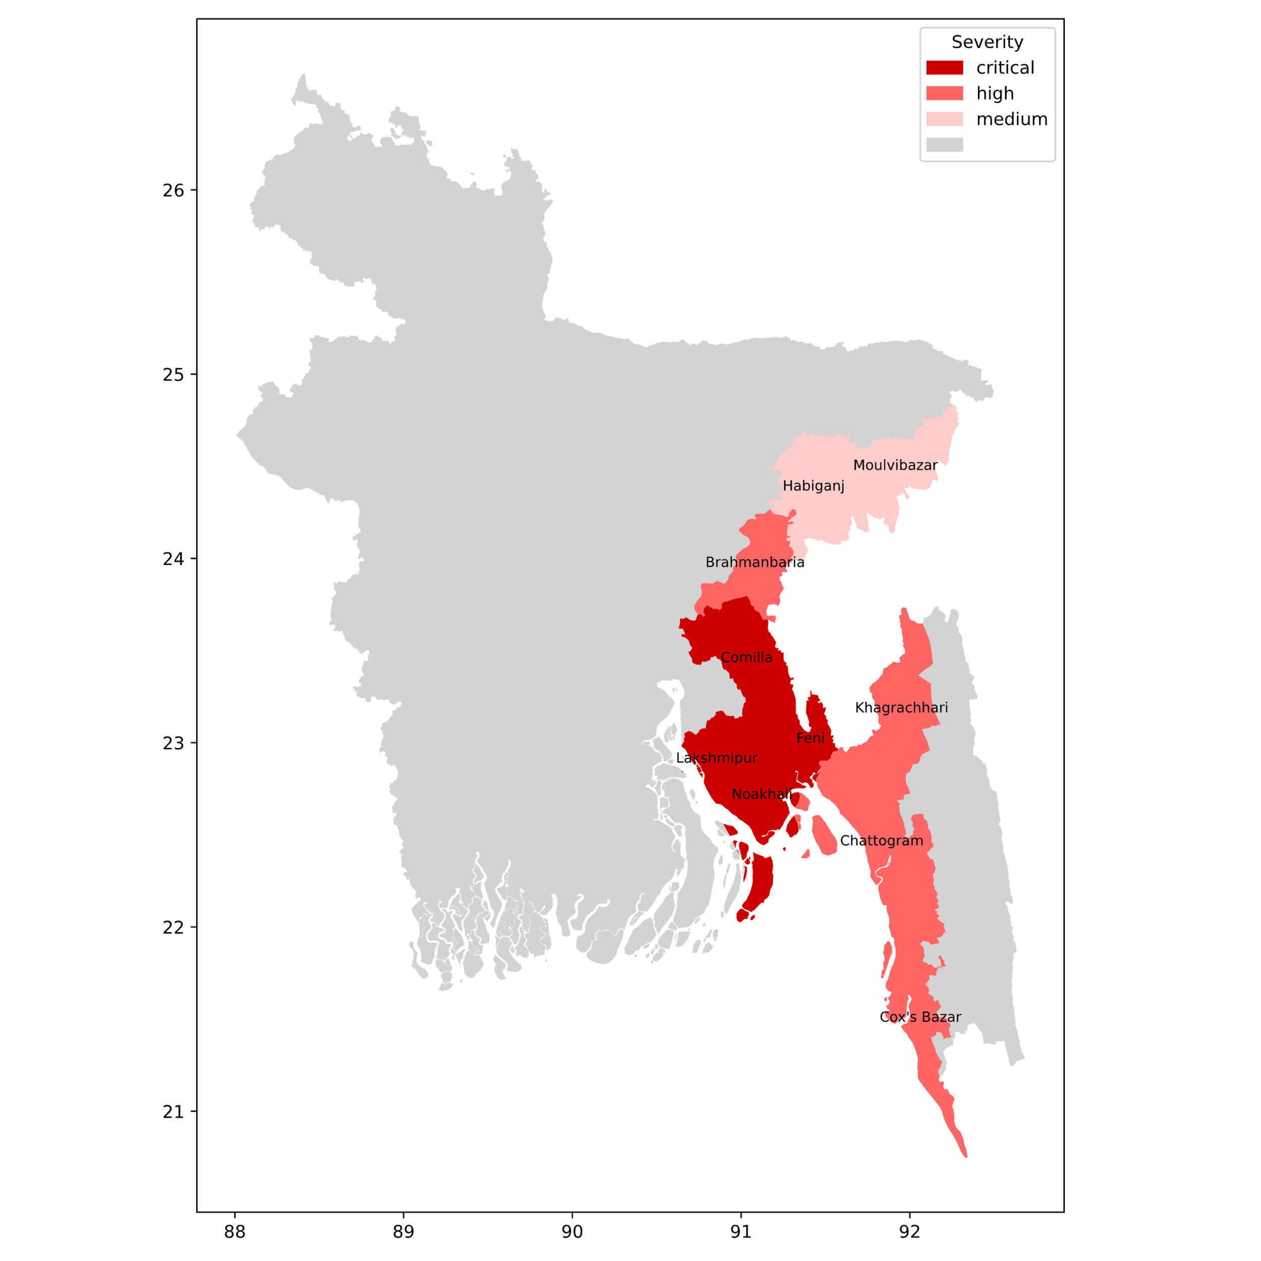

Figure 2 Floor severity in affected districts

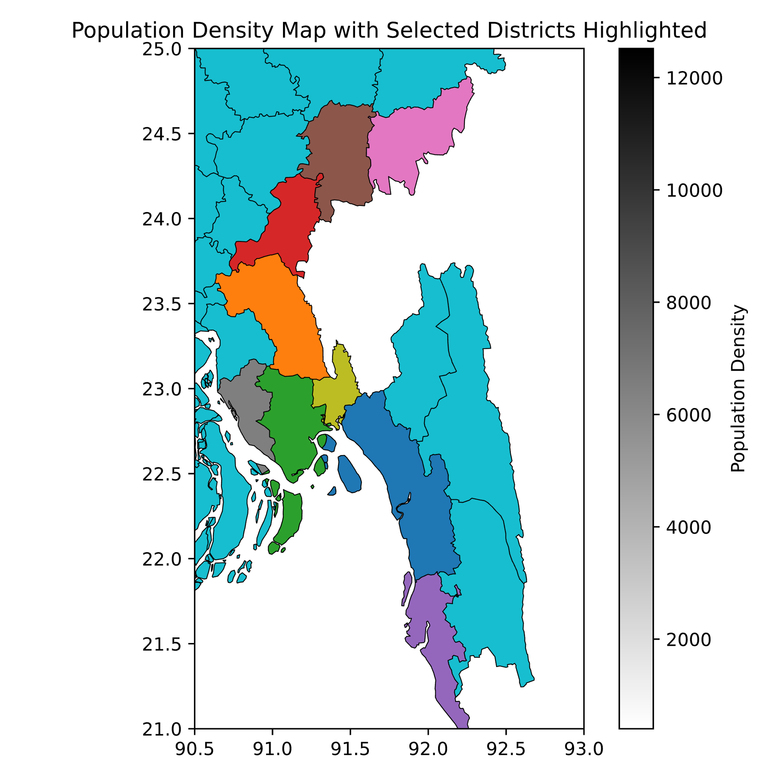

Figure 3 Population density

## Optimization network and analysis of relief distribution

The mathematical model is implemented using Gurobi, with variables x for routes and y for shelter coverage.

## Web application (think about a name)

How this web app can be useful, and what is typical inputs and outputs of the app++ . Input of the web application (from user): newly available relief amount

Expected output:

Screenshot from app, and tabular output (for stakeholders)

Anylogic, and AIMMS platform (they have some amazing tabular format output for easy interpretation) can be useful reference to build the app.

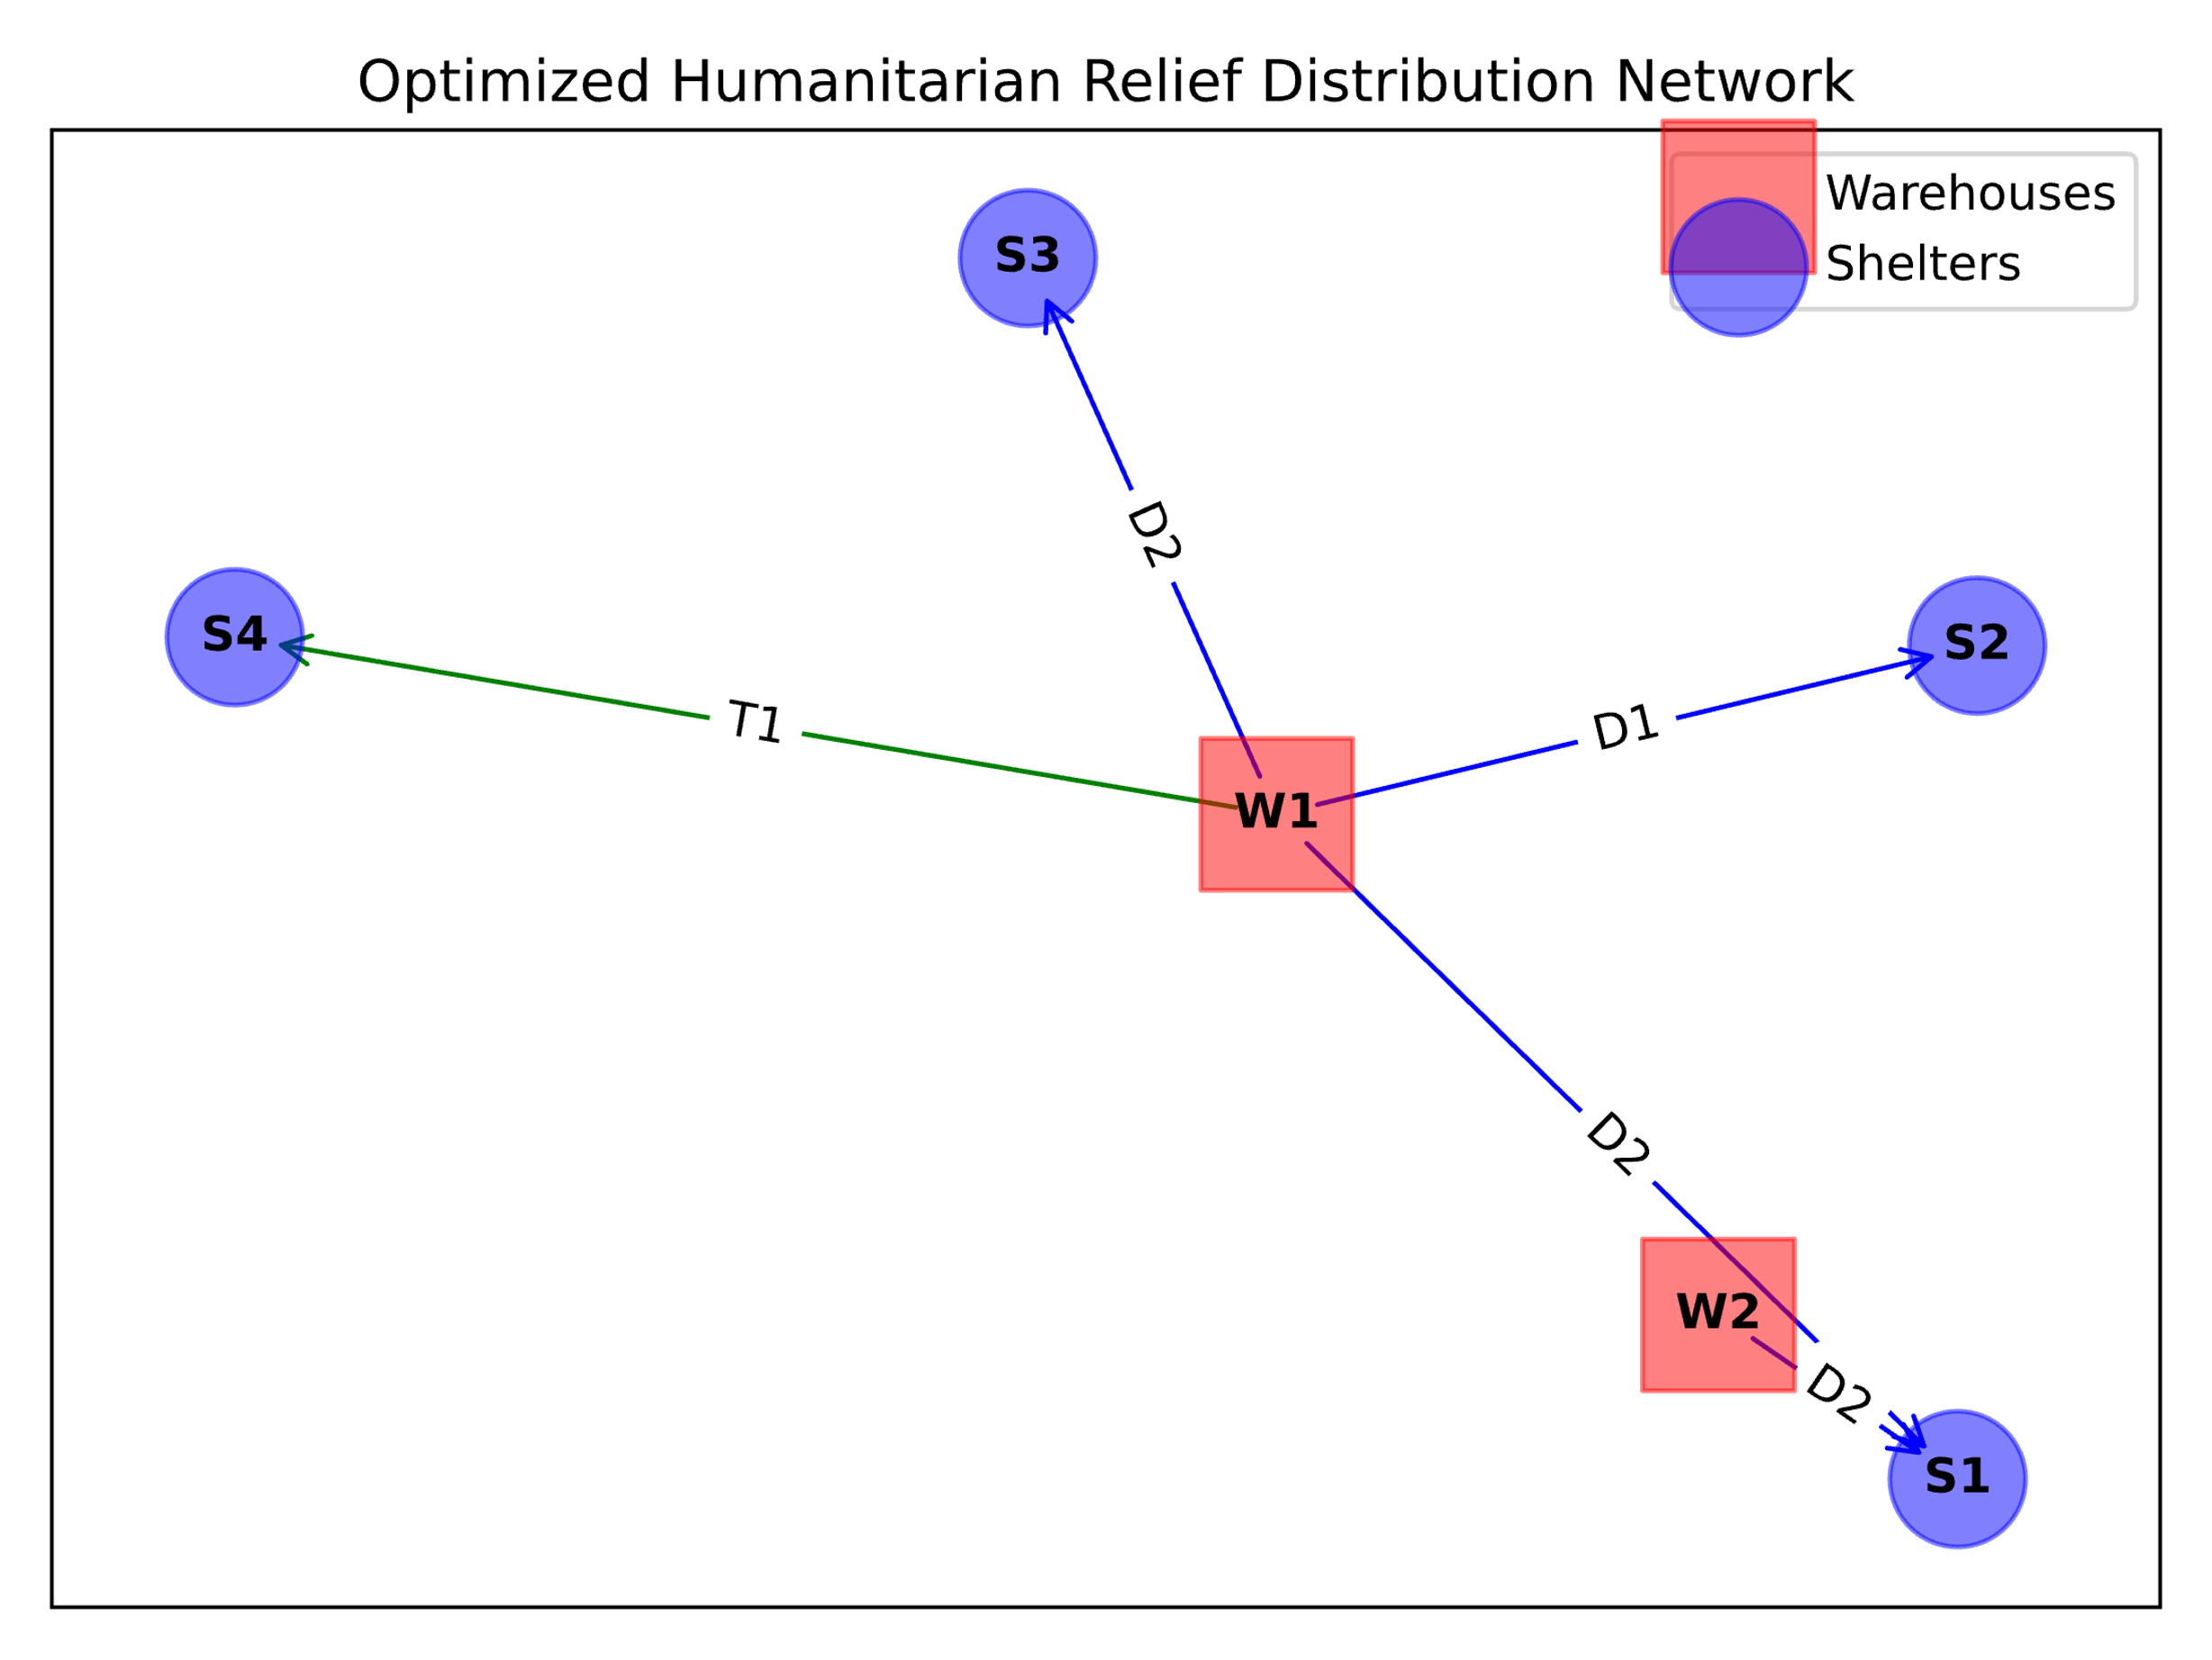

Figure 4 Optimized relief distribution network (will add GIS map, and data for Feni++)

## Challenges, Limitations, and future works

Challenges (Brainstormed with Riad):

1. Most Bangladesh Army base locations are NOT open-source

Emergency response in Bangladesh is often at community level (getting data at national level is almost impossible, partly due to security reasons)

# Conclusion

++

**Supplementary resources**

<https://github.com/tanmoyie/Optimizing-flood-reponse-in-Bangladesh>

**Authors’ contribution**

***Md Mahbubar Rahman:*** original research idea, optimization model development, solution algorithm; ***Tanmoy Das:*** optimization model development, data curation and analysis; ***Riad Alam:*** Domain experience, data collection; ***Hafizur Rahman:*** model deployment, validation

**Reference**

Paul, Ruma. 2024. “Twenty Dead, 5 Million Affected in Bangladesh Floods.” Yahoo News. 2024. https://au.news.yahoo.com/twenty-dead-5-2-million-145537062.html.

protirodh.net. 2024. “প্রতিরোধ.Net.” Https://Protirodh.Net/Flood. 2024. https://protirodh.net.

ReliefWeb. 2024. “Flooding in Eastern Bangladesh (Feni, Comilla, Noakhali, Habiganj, Moulvibazar, Khagracchari and Rangamati).” 2024. https://reliefweb.int/report/bangladesh/flooding-eastern-bangladesh-feni-comilla-noakhali-habiganj-moulvibazar-khagracchari-and-rangamati-briefing-note-24082024.